Vetiver Oil – The Earthy Essence of Calm & Balance
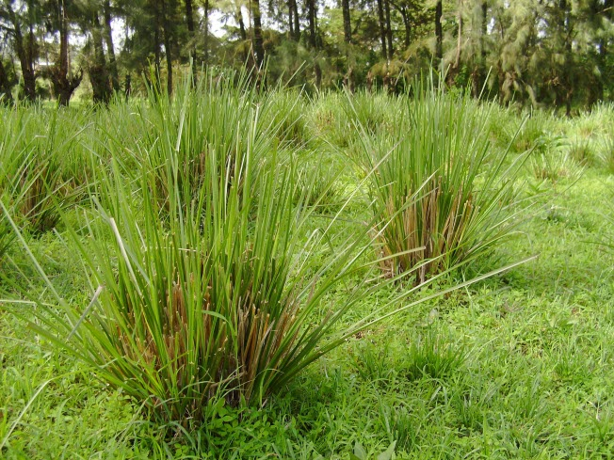
The Export Express proudly offers 100% Pure Vetiver Essential Oil (Vetiveria zizanioides) — a premium-grade aromatic extract revered for its woody, grounding, and deeply calming scent. Extracted through steam distillation of vetiver roots, this luxurious essential oil stands as one of the most treasured ingredients in perfumery, aromatherapy, and natural skincare worldwide.

Origin and Extraction
- Botanical Name: Vetiveria zizanioides (also known as Khus or Vetivert)
- Plant Part Used: Roots
- Extraction Method: Steam Distillation
- CAS Number: 8016-96-4
- Country of Origin: India (also cultivated in Haiti and Indonesia)
- Appearance: Amber to dark brown liquid
- Aroma: Sweet, woody, earthy, and smoky
- Specific Gravity: 0.970 – 0.978 at 20°C
- Refractive Index: 1.520 – 1.550 at 20°C
- Solubility: Soluble in alcohol and oils; insoluble in water
Our Indian vetiver oil is carefully distilled to preserve its natural depth and purity, ensuring a therapeutic-grade product for both cosmetic and industrial applications.

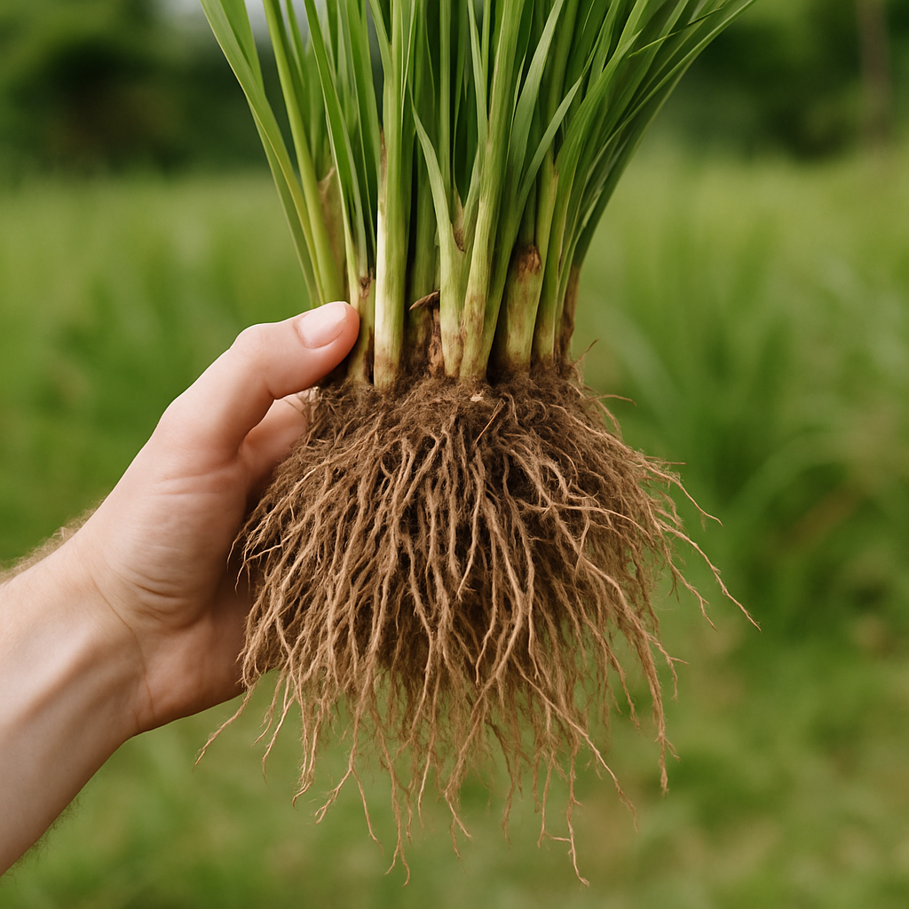

Key Constituents
The rich composition of Vetiver oil contributes to its therapeutic excellence and aromatic depth:
- Vetiverol
- Vetivone
- Khusimol
- Isovalencenol
- Alpha-Vetivone and Beta-Vetivone
These compounds lend Vetiver oil its distinct woody aroma, viscosity, and natural ability to calm and restore emotional balance.

Aromatic & Therapeutic Benefits
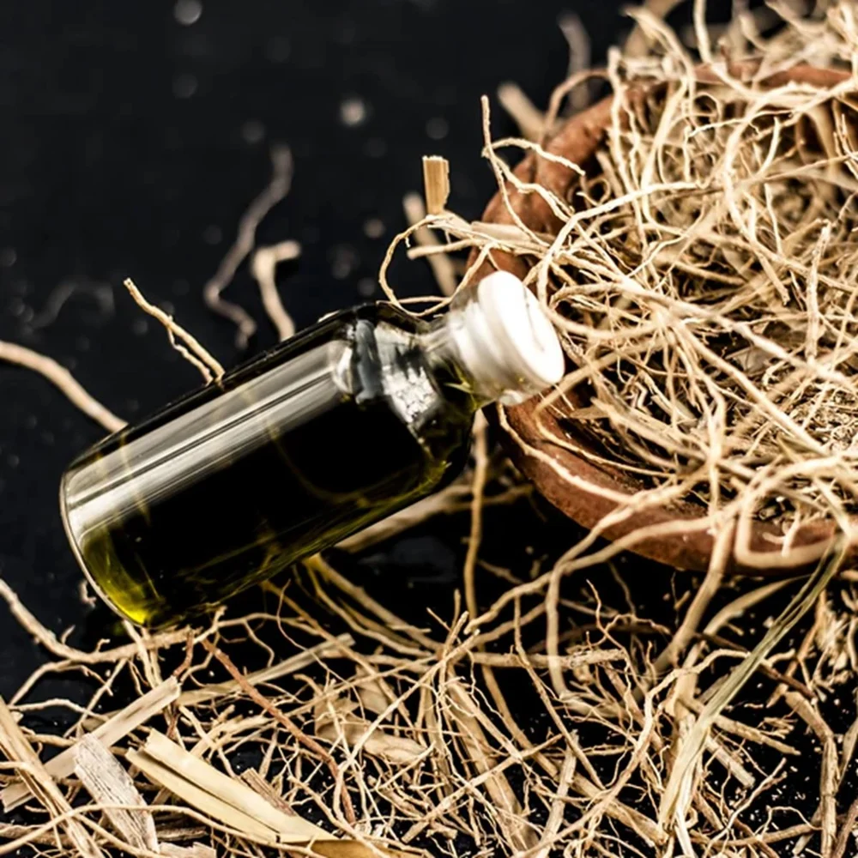

1. Emotional Balance & Relaxation
Vetiver oil is widely used in aromatherapy for its grounding, centering, and stress-relieving properties. It promotes tranquility and helps calm nervous tension, making it ideal for diffusers and massage blends.

2. Sleep & Mental Clarity
The oil’s soothing aroma supports restful sleep and reduces symptoms of anxiety, restlessness, and overthinking — earning it the nickname “The Oil of Tranquility.”

3. Skincare & Cosmetic Applications
Vetiver’s antiseptic and regenerative qualities make it a valuable addition to skincare formulations. It helps rejuvenate dry, irritated, and aging skin, supports wound healing, and enhances natural glow.

4. Pain Relief & Circulation
Applied in diluted form, vetiver oil is known to ease muscle stiffness, rheumatic pain, and arthritis, while improving blood circulation.

5. Perfumery & Blending
Due to its long-lasting base note, Vetiver oil is a key ingredient in high-end perfumes and colognes. It blends harmoniously with:
- Sandalwood
- Jasmine
- Patchouli
- Lavender
- Rose
- Cedarwood

Types of Vetiver Oil in Global Demand

1. Indian Vetiver Oil (Khus)
Rich, earthy, and deeply grounding — known for its warmth and traditional Ayurvedic use. Ideal for cosmetic and aromatherapy blends.

2. Haitian Vetiver Oil
The most premium and aromatic variety, characterized by its smoky, woody depth and use in luxury perfumes. Globally recognized for its refined scent and exceptional stability.

3. Indonesian Vetiver Oil
A sharper, more intense aroma compared to Indian and Haitian types — often used in industrial fragrance formulations.

Therapeutic Properties
Property | Benefit
Antiseptic | Protects against infections and skin irritation
Nervine | Strengthens the nervous system
Cicatrisant | Aids in wound and scar healing
Aphrodisiac | Enhances emotional connection and sensuality
Sedative | Promotes deep relaxation and sleep
Tonic | Revitalizes the body and mind

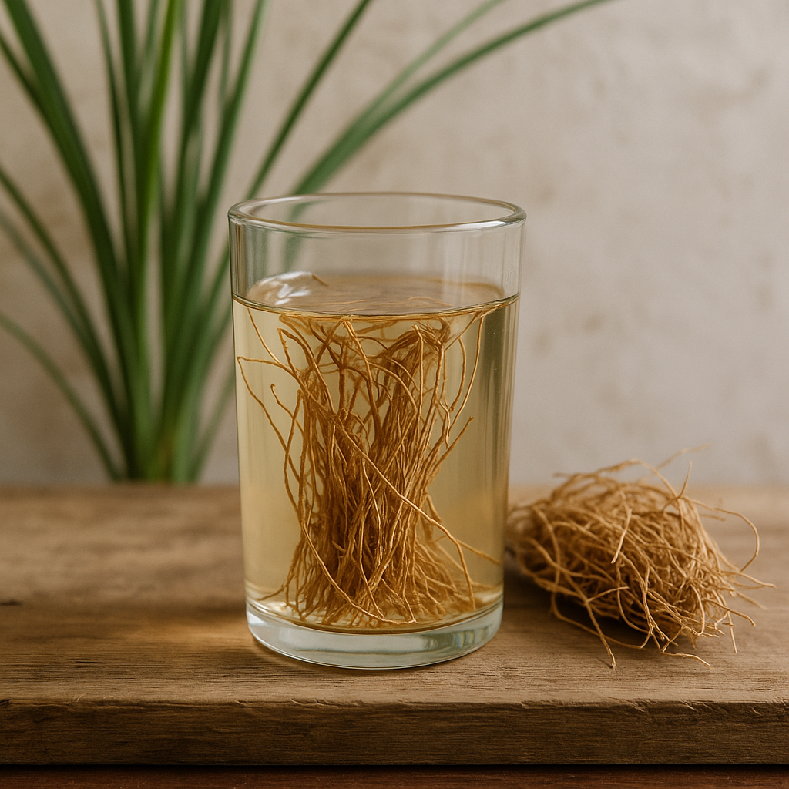
Applications Across Industries

1. Aromatherapy & Spa
Vetiver essential oil is used in diffusers, massage oils, and meditation blends to promote emotional calm and balance.

2. Cosmetics & Skincare
Commonly found in creams, serums, and lotions, vetiver rejuvenates and tones skin, offering a natural anti-aging effect.

3. Perfumery
Used as a base note in luxury fragrances due to its long-lasting earthy scent and fixative qualities.

4. Pharmaceuticals
Valued for its anti-inflammatory and antiseptic properties, vetiver oil is also used in Ayurvedic and herbal medicinal preparations.

5. Home & Personal Care
Incorporated into candles, air fresheners, soaps, and natural deodorants for its pleasant and grounding fragrance.

Technical Specifications
Parameter | Specification
Form | Liquid
Color | Amber to Grayish Brown
Odor | Woody, Earthy, Sweet
Purity | 100% Pure and Natural
Extraction Method | Steam Distillation
Shelf Life | 24 Months
Packaging Options | 1 kg, 5 kg, 25 kg & 180 kg drums
Storage | Store in a cool, dry place away from sunlight

Precautions & Safety
- Always dilute before topical application (2–3% dilution recommended).
- Avoid use during pregnancy or by individuals with sensitive skin.
- For external use only — not for ingestion.

Sustainability & Ethical Sourcing
At The Export Express, we ensure that every batch of Vetiver oil is ethically sourced from trusted farmers in India and processed using eco-friendly steam distillation techniques.
Our supply chain supports sustainable harvesting practices, ensuring soil conservation and biodiversity preservation.

Why Choose The Export Express for Vetiver Essential Oil?
- ✅ 100% Pure & Natural, Steam-Distilled Oil
- ✅ Export-Quality Packaging (1 kg to 180 kg)
- ✅ Available in bulk supply for B2B & OEM orders
- ✅ Tested for purity, consistency, and safety
- ✅ Trusted by aromatherapy, cosmetic, and perfume manufacturers worldwide

We Export More Than Just Vetiver Oil
The Export Express is a global exporter of premium essential oils — including Rose, Jasmine, Sandalwood, Lavender, Tea Tree, and more.
Share your technical specifications and intended use, and our team will provide customized formulations and bulk export solutions tailored to your business needs.

Experience the Tranquility of Nature — with The Export Express Vetiver Oil.
Whether for luxury perfumery, holistic wellness, or natural skincare — our Vetiver Essential Oil captures the earth’s purest essence in every drop.

